Payout Trustee Approval - [Phase 1]
Author: Sajid Shaikh
Team/Pod: Payouts Experience | BU: RazorpayX
Published Date: May 31, 2023

Reviewer Name | Reviewed Date | Status
Krishna Mutyala |  | Not started
R Supreeth |  | Not started

Table of Contents

1. Problem Statement 0
2. Introduction 0
2.1. Relevant Resources 0
3. In Scope 0
4. Out of Scope 0
5. Assumptions & Goals 0
5.1. Assumptions 0
5.2. Goals 0
6. Current Approach - Payout Approve API Flow 0
6. Final Approach - Specifications 0
6.1. Account Setup 0
6.2. OAuth token generation flow 0
6.3. Approval flow 0
6.4. Payout Approve API Flow 0
6.5. Missed Webhooks 0
6.5.1. Missed Pending Payout Webhook 0
6.5.2. Missed Payout Terminal status Webhook 0
6.6. Other Possible Solution 0
6.7. Contract Changes 0
6.7.1 Payout Webhook Payload Change 0
6.7.2 Payout Approve/Reject API contract change 0
Current response 0
Payload change 0
6.8. Workflow Setup 0
8. Testing Plan 0
9. Go-live plan 0
9.1. Production Rollout 0
9.2. Rollback plan 0
10. Monitoring & Logging 0
11. Timelines 0
12. Security concerns 0
1. How do we ensure that payout is always verified by the trustee and does not directly get processed after creation? 0
2. How will we identify the origin for a particular payout approval? 0
3. How do we safeguard the configured webhook urls to avoid SSRF attacks? 0
4. What will happen if a payout is approved twice by the trustee? Will the payout be processed twice? 0
5. Since the trustee ERP system will have mapping for multiple merchants and their access tokens, what if they try to use one merchant's payout using another merchant's access token? 0
6. Is there any money loss scenario that can occur with this setup? 0
13. Appendix 0
14. Open questions 0

1. Problem Statement
As per the P2P RBI guidelines, all P2P lending platforms should operate two escrow accounts. One for funds received from lenders and pending disbursal, and the other for collections from borrowers, shall be maintained.
The guidelines also mandate that all escrows have to be operated by a bank-promoted escrow trustee and that the platform will have view-only access to the account. This means all disbursals (loan disbursal and investor withdrawal) have to be processed by the trustee.
Currently, this is a manual process for the trustee to approve the disbursals for P2P platform. This is tedious and time consuming for the trustee. Also, the expected approval time for P2P’s disbursals are high.

2. Introduction
As part of the current enhancement, we are looking to provide a solution to make the Trustee approval simpler and time efficient by automating it. To start with, we are collaborating with Axis Trustee to have the ERP system in place.
We need to solve for the following
- RazorpayX account setup for P2P platforms such that the RBI guidelines for Trustee to have full control over the P2P platform’s Escrow account and approve their disbursals is being adhered to.
- Payout approvals by trustees using APIs while restricting the actions that the ERP system can do for the P2P platforms.

2.1. Relevant Resources
Link to Product Spec - Link

3. In Scope
We already have payout approve and reject API’s available over private auth which we will be reusing for trustee approvals.
- Payout Approve and Reject APIs will need the following changes
  - Attach new trustee approval specific OAuth Scope for these APIs.
  - Current APIs have OTP verification step baked in. For Bearer auth with appropriate scope, we will be skipping otp verification step.
  - We have to validate that the bearer token is authorized to act on the incoming payout approval.
- Payout webhooks should be received by both, maker (fintech or P2P platform) and checker (Trustee)
- Payout webhooks need to include fund account and contact details instead of just the fund account id. This will be behind a feature flag `enable_payout_approval_by_partner`.
- Fetch Multiple Payouts, Fetch Payout detail, Fetch Fund Account detail and Fetch Contact detail APIs should be accessible to the ERP over Oauth and also bypass IP whitelisting for these APIs.
- Request logging should be enabled for Payout approve/reject APIs in order to save IPs of the approver.

4. Out of Scope
- Webhooks for fund account creation.
- Webhooks for contact creation.
- Audit Reports for payout approvals by ERP.
- Auto rejection of pending payouts after a certain time period.
- Blocking the owner role (trustee) for payout creation.

5. Assumptions & Goals

5.1. Assumptions
- ERP system will sign up as a platform partner on Razorpay in order to create an application.
- In case a webhook is missed, ERP will use the fetch APIs available for payouts, fund account and contact to get the missed payout and account details.
- ERP will have an OAuth token generated for every merchant and saved against a merchant ID and account number on their side, which will be used for communication with Razorpay APIs.
- API keys will not be shared by the trustee with the ERP system.
- There will be no additional changes required in workflow processing.
- ERP system will use the Razorpay OAuth APIs in order to generate/revoke the access tokens.
- Contacts created by platform will contain PAN details in the reference_id field of the entity.
- Payouts created by platform will contain borrower to lender mapping details in the reference/notes fields of the entity.

5.2. Goals
- Onboard P2P platforms along with their fintechs on RazorpayX such that their Escrow account is governed by Trustees.
- Allow Trustee’s ERP system to access approval APIs via OAuth.
- Send out webhooks to ERP and P2P platforms to notify majorly whenever payout goes in pending/created/rejected state.

6. Current Approach - Payout Approve API Flow
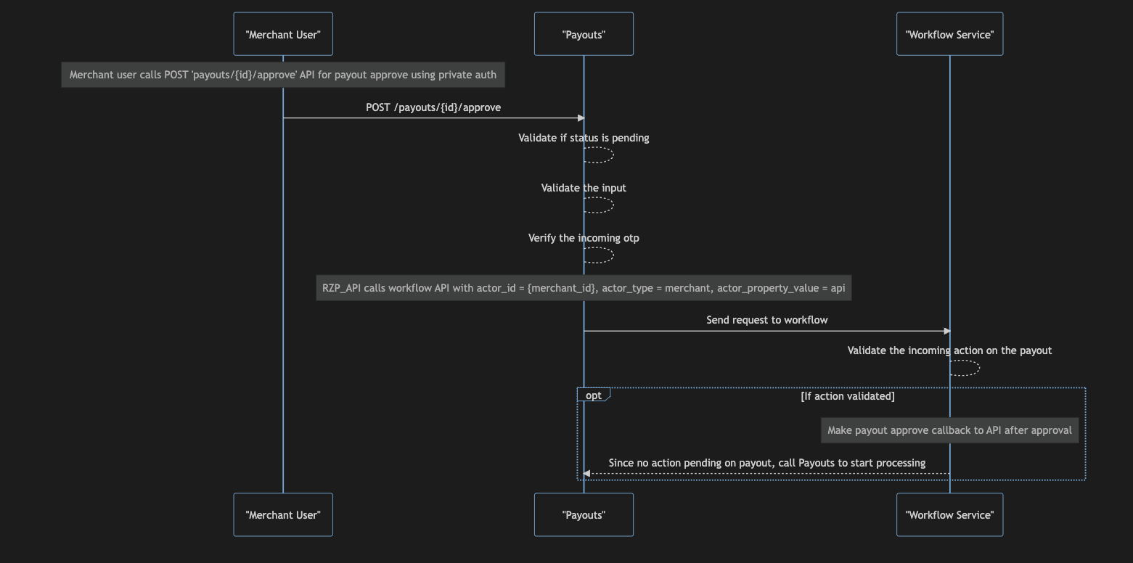

6. Final Approach - Specifications

6.1. Account Setup
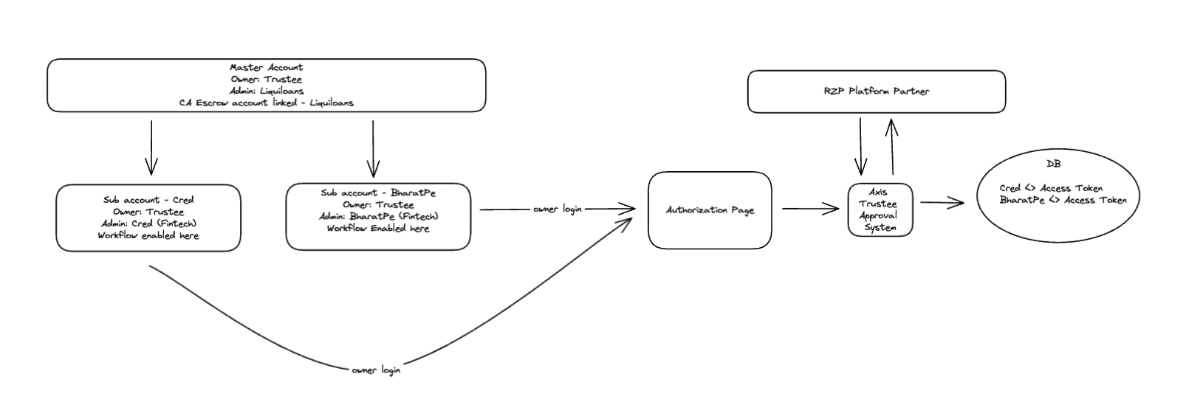
Example:
Master account:
Owner: Trustee
Admin: Liquiloans(NBFC)
Sub Account:
Owner: Trustee
Admin: Fintechs(Cred/Bharat)

- Master Account will be linked with NBFCs Escrow account and the owner will be Trustee
- NBFC (liquiloans) will be added as an Admin user with create/view payouts rights on the master account.
- For every fintech associated with the NBFC, we will create a sub account. For example, Cred (Fintech) will be a sub account that will be created under liquiloans (NBFC).
- Subaccounts will also be owned by the Trustee. Fintech (Cred) will be added as an Admin user with create/view payouts rights on the sub account.
- Axis ERP system will be registered as a Platform partner on razorpay. It will host an endpoint for generating bearer token for the Fintechs
- ERP system will have a merchant_id <> account_number <> access_token mapping in its db upon successful authorization by the trustee. Token generation flow using OAuth service is available here
- This token can be used to access the approval api by ERP in order to approve/reject a payout.
- Workflow will be enabled on the sub-accounts in order to mandate owner (Trustee) approval on payouts created by the Fintech’s (Cred).

6.2. OAuth token generation flow
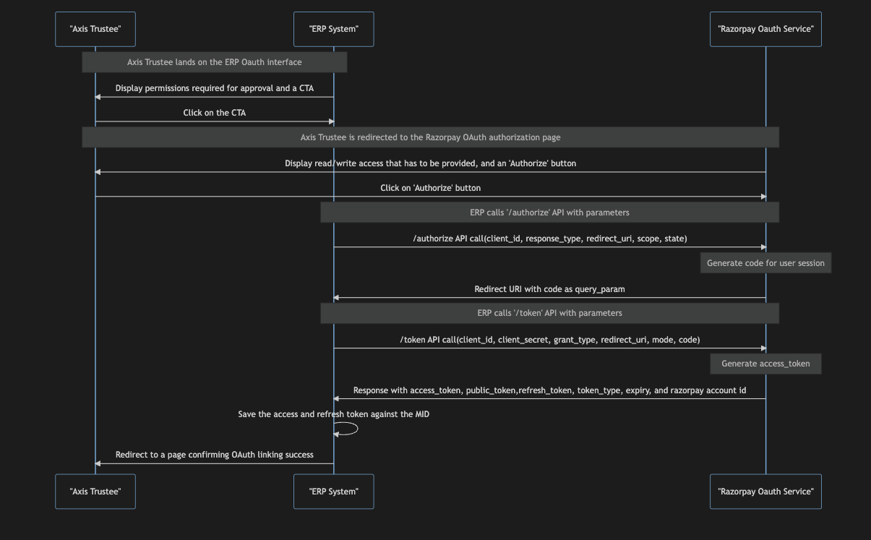

- ERP system will have the client_id and client_secret configured upon signing up as a platform partner and creating an application
- ERP system will expose an interface for Axis trustee to initiate the OAuth linking
- Axis trustee will login to their merchant dashboard and then initiate the OAuth linking.
- ERP system will use the APIs exposed by Razorpay OAuth to generate a bearer token. OAuth API details can be found here
- Upon successful generation of the token, ERP system will save the generated access and refresh tokens against the Merchant Id and Account ID.
- This access token can be used to communicate with the approval api for a merchant.

6.3. Approval flow
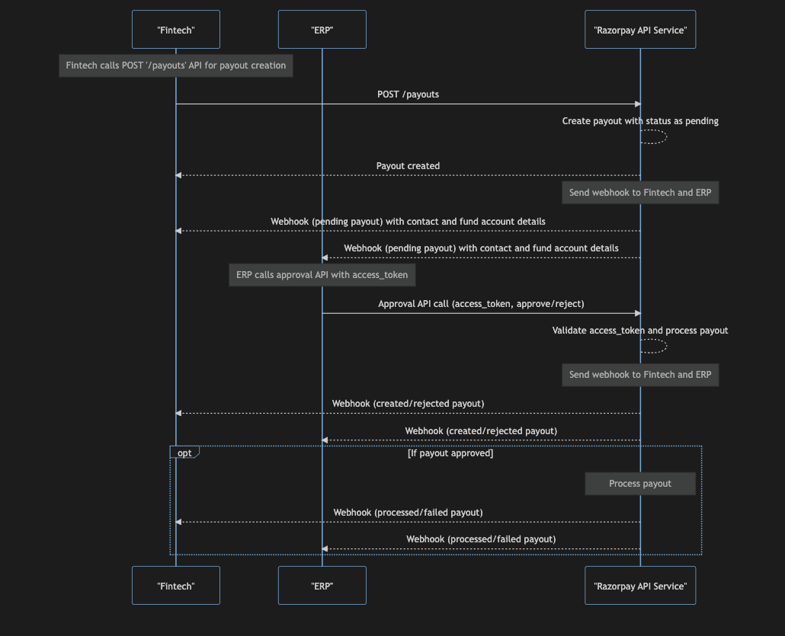

- When Fintech (Cred) creates a payout, it will go in a pending state as per the configured workflow.
- Webhook for payout.pending will be sent on the configured urls
- ERP system will use the access_token based on the merchant id passed in the webhook and call the approval api to approve/reject the payout
- Payouts API will validate if the merchant id for the incoming payout and the merchant id for the token is the same and then proceed with the approval accordingly.
- In case the payout was rejected, payout.rejected webhook will be sent to the maker & checker.
- In case the payout was approved, payout.created/payout.initiated webhook will be sent to the maker & checker.
- payout.queued webhook will be sent to the maker & checker incase the payout is queued after approval
- payout.processed/payout.failed/payout.reversed webhooks will be sent to the configured urls when payout reaches a terminal state.

6.4. Payout Approve API Flow
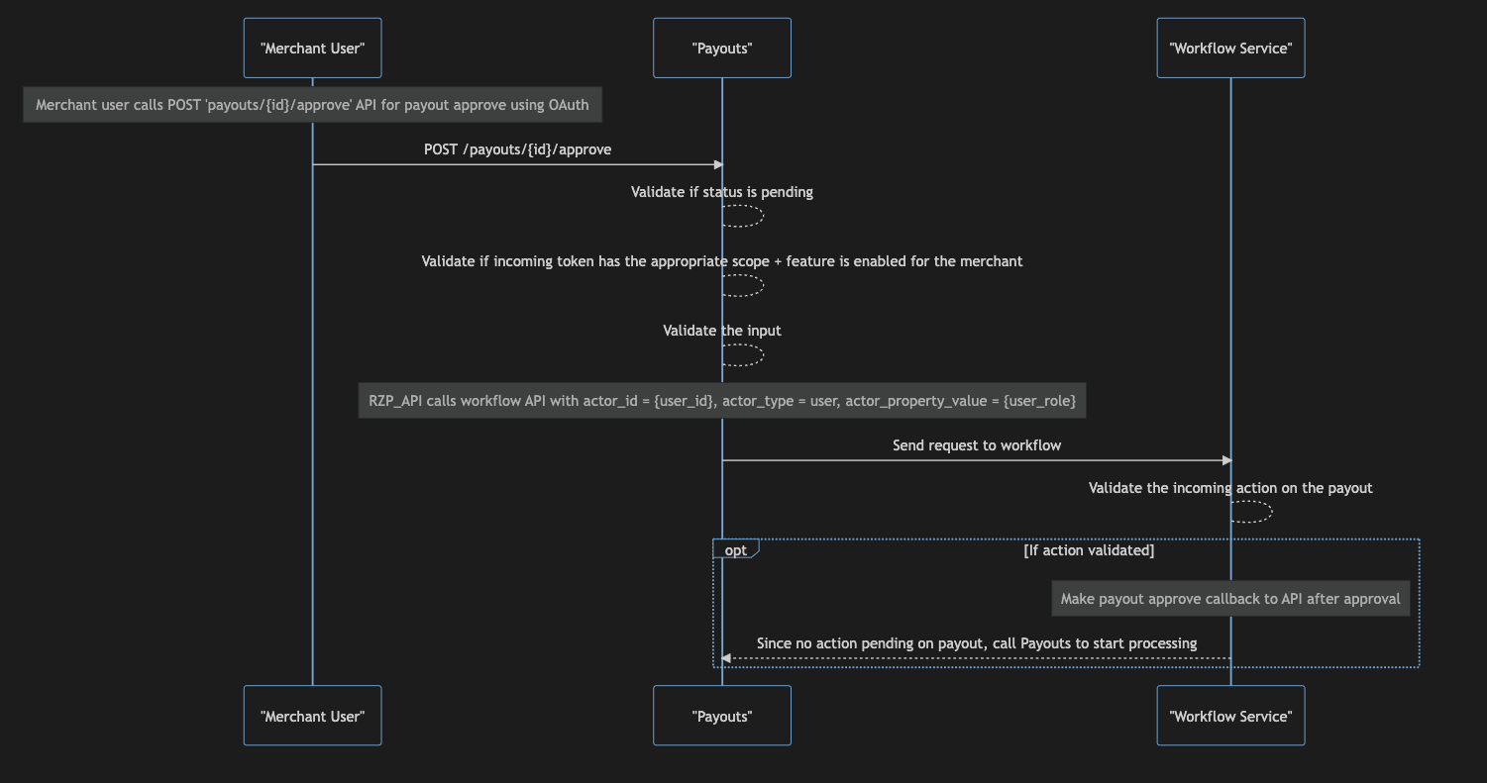

6.5. Missed Webhooks

6.5.1. Missed Pending Payout Webhook
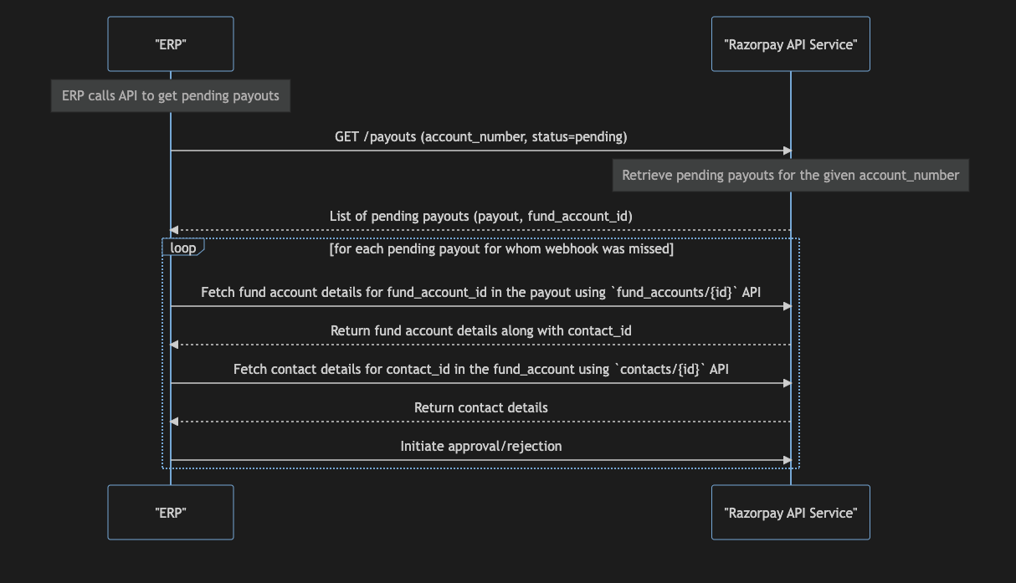

- ERP system can hit the fetch payouts api to retrieve the pending payouts in case webhook fails for any reason. Details of this api can be found here.
- API will return pending payouts for a merchant which the ERP system.
- ERP can check the payouts for whom webhook was missed. For these payouts they can hit the fetch fund account and contact APIs to get details.
- ERP can then initiate approval/rejection for these payouts.

6.5.2. Missed Payout Terminal status Webhook
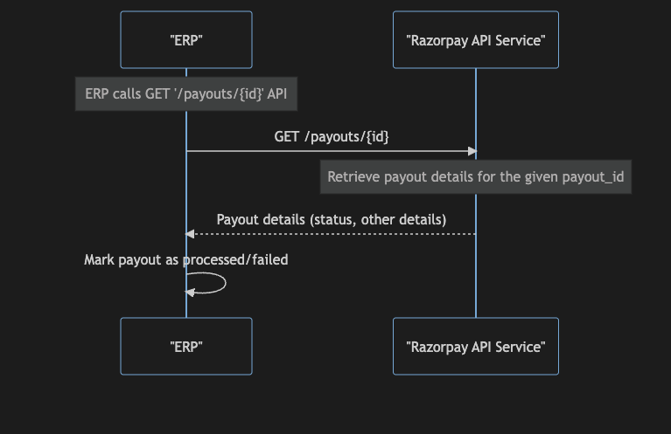

- ERP system can hit the fetch payout api to retrieve the details of a pending payouts in case webhook fails for any reason. Details of this api can be found here
- API will return the payout details and ERP system can mark the payout to the status returned in this api or wait in case the status is still processing.

6.6. Other Possible Solution
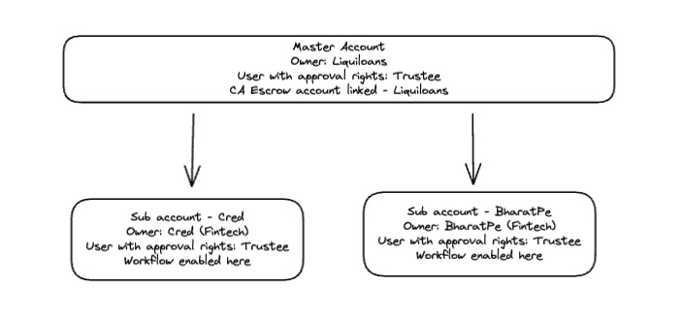
Example:
Master account:
Owner: Liquiloans (NBFC)
User with approval rights: Trustee
Sub Account:
Owner: Fintechs(Cred/Bharat)
User with approval rights: Trustee

- In this setup we onboard the P2P platform as a merchant with its Escrow account linked.
- P2P platform will have sub accounts created for fintechs under it
- Trustee will be added as a normal user with approval rights
- Workflow will be enabled for trustee approval and editing of workflow would be disabled so that owner cannot remove trustee approval step

We cannot go ahead with this solution since from the legal point of view, the guidelines strictly says that the Escrow account of the P2P platforms should be fully controlled by the trustee.
In the shortlisted solution, by ensuring that the trustee is the merchant on record, with the right checks of balance in place, the setup will be compliant and at the same time have checks to prevent misuse from either of the parties.

6.7. Contract Changes

6.7.1 Payout Webhook Payload Change
We will add `fund_account` and `contact` details in the payout webhook that is sent. Currently we only send the `fund_account_id` and not fund_account and contact details. This change will be behind a feature flag `enable_payout_approval_by_partner`.

{
"entity": "event",
"account_id": "acc_BfVUrG6tDiL7H0",
"event": "payout.pending",
"contains": [
"payout"
],
"payload": {
"payout": {
"entity": {
"id": "pout_1Aa00000000001",
"entity": "payout",
"fund_account": {
"id": "fa_F681qr6Bqy1Je7",
"entity": "fund_account",
"contact_id": "cont_F681qmU11CfPDl",
"contact": {
"id": "cont_F681qmU11CfPDl",
"entity": "contact",
"name": "Gaurav Kumar",
"contact": "9876543210",
"email": "gaurav.kumar@example.com",
"type": "employee",
"reference_id": "Acme Contact ID 12345",
"batch_id": null,
"active": true,
"notes": {
"notes_key_1": "Tea, Earl Grey, Hot",
"notes_key_2": "Tea, Earl Grey… decaf."
},
"created_at": 1592929016
},
"account_type": "bank_account",
"bank_account": {
"ifsc": "HDFC0001234",
"bank_name": "HDFC Bank",
"name": "Gaurav Kumar",
"notes": [],
"account_number": "1121431121541121"
},
"batch_id": null,
"active": true,
"created_at": 1592929016
},
"amount": 100,
"currency": "INR",
"notes": {
"note_key 1": "Tea. Earl Gray. Hot.",
"note_key 2": "Tea. Earl Gray. Decaf."
},
"fees": 0,
"tax": 0,
"status": "pending",
"purpose": "refund",
"utr": null,
"mode": "NEFT",
"reference_id": null,
"narration": "Test Fund Transfer",
"batch_id": null,
"status_details": {
"description": "Confirmation of the credit to the beneficiary is pending from HDFC bank. Please check the status after after 24th October 2021, 10:40 PM",
"source": "beneficiary_bank",
"reason": "beneficiary_bank_confirmation_pending"
},
"created_at": 1580808301,
"fee_type": ""
}
}
},
"created_at": 1580808301
}



6.7.2 Payout Approve/Reject API contract change

API Name | Approve payout API
Method | POST
Endpoint | v1/payouts/{id}/approve
Request parameters | {user_comment: ‘’, otp: ‘’, token: ‘’, remarks:’approved’}
Auth | Private

API Name | Reject payout API
Method | POST
Endpoint | v1/payouts/{id}/reject
Request parameters | {user_comment: ‘’, otp: ‘’, token: ‘’, remarks:’rejected’}
Auth | Private

Current response

{
"entity" : "payout",
"fund_account_id" : "fa_100000000000fa",
"amount" : 10000,
"currency" : "INR",
"transaction_id" : null,
"pending_on_user" : true,
"workflow_history" : {
"config_id" : "FV0aQGxYU4kk4c",
"entity_type" : "payouts",
"title" : "title",
"description" : "{}",
"config_version" : "1",
"creator_id" : "10000000000000",
"creator_type" : "merchant",
"diff" : {
"old" : {
"amount" : null,
"merchant_id" : null
},
"new" : {
"amount" : 10000,
"merchant_id" : "10000000000000"
}
},
"callback_details" : {
"state_callbacks" : {
"created" : {
"method" : "post",
"payload" : {
"queue_if_low_balance" : true,
"type" : "state_callbacks_created"
},
"headers" : {
"x-creator-id" : ""
},
"service" : "api_live",
"type" : "basic",
"response_handler" : {
"type" : "success_status_codes",
"success_status_codes" : {
201,
200
}
}
},
"processed" : {
"method" : "post",
"payload" : {
"queue_if_low_balance" : true,
"type" : "state_callbacks_processed"
},
"headers" : {
"x-creator-id" : ""
},
"service" : "api_live",
"type" : "basic",
"response_handler" : {
"type" : "success_status_codes",
"success_status_codes" : {
201,
200
}
}
}
},
"workflow_callbacks" : {
"processed" : {
"domain_status" : {
"approved" : {
"method" : "post",
"payload" : {
"queue_if_low_balance" : true,
"type" : "workflow_callbacks_approved"
},
"headers" : {
"x-creator-id" : ""
},
"service" : "api_live",
"type" : "basic",
"response_handler" : {
"type" : "success_status_codes",
"success_status_codes" : {
201,
200
}
}
},
"rejected" : {
"method" : "post",
"payload" : {
"queue_if_low_balance" : true,
"type" : "state_callbacks_rejected"
},
"headers" : {
"x-creator-id" : ""
},
"service" : "api_live",
"type" : "basic",
"response_handler" : {
"type" : "success_status_codes",
"success_status_codes" : {
201,
200
}
}
}
}
}
}
},
"status" : "initiated",
"domain_status" : "created",
"owner_id" : "10000000000000",
"owner_type" : "merchant",
"org_id" : "100000razorpay",
"states" : {
"Owner_Approval" : {
"workflow_id" : "FV58BuqLuCP4Cw",
"status" : "created",
"name" : "Owner_Approval",
"group_name" : "ABC",
"type" : "checker",
"rules" : {
"actor_property_key" : "role",
"actor_property_value" : "owner",
"count" : 1
},
"pending_on_user" : true,
}
},
"type" : "payout-approval",
"pending_on_user" : true
},
"notes" : {
"random_key1" : "Hello",
"random_key2" : "Hi"
},
"fees" : 0,
"tax" : 0,
"status" : "processing",
"purpose" : "refund",
"utr" : null,
"user_id" : null,
"mode" : "NEFT",
"reference_id" : null,
"narration" : "Test Merchant Fund Transfer",
"batch_id" : null,
"cancelled_at" : null,
"queued_at" : null,
"banking_account_id" : "bacc_1000000lcustba",
"initiated_at" : null,
"processed_at" : null,
"reversed_at" : null,
"failed_at" : null,
"rejected_at" : null,
"failure_reason" : null,
"fee_type" : null,
"scheduled_at" : null,
"scheduled_on" : null
}



Payload change
We will be removing the `workflow_history` field from this response as we dont want to expose the workflow details externally. This change will only be made for approve/reject API calls made using the proposed OAuth scope.

{
"entity" : "payout",
"fund_account_id" : "fa_100000000000fa",
"amount" : 10000,
"currency" : "INR",
"transaction_id" : null,
"pending_on_user" : true,
"notes" : {
"random_key1" : "Hello",
"random_key2" : "Hi"
},
"fees" : 0,
"tax" : 0,
"status" : "processing",
"purpose" : "refund",
"utr" : null,
"user_id" : null,
"mode" : "NEFT",
"reference_id" : null,
"narration" : "Test Merchant Fund Transfer",
"batch_id" : null,
"cancelled_at" : null,
"queued_at" : null,
"banking_account_id" : "bacc_1000000lcustba",
"initiated_at" : null,
"processed_at" : null,
"reversed_at" : null,
"failed_at" : null,
"rejected_at" : null,
"failure_reason" : null,
"fee_type" : null,
"scheduled_at" : null,
"scheduled_on" : null
}



6.8. Workflow Setup
We will set up a workflow on the Account where every payout will need an owner user approval before proceeding with the processing.

Workflow will look like this,
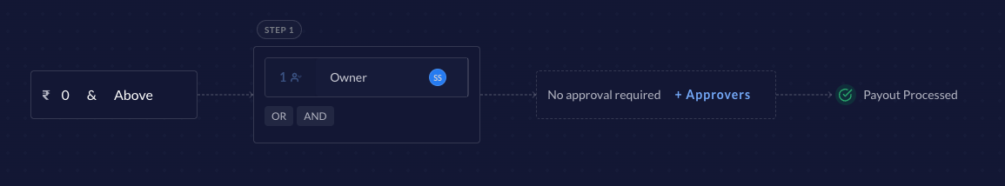

The workflow config will look something like this,

entity_id = <payout_id>
entity_type = 'payout'
actor_id = '<user_id>'
actor_type = 'user'
actorPropertyKey = 'role'
actorPropertyvalue = 'owner'


8. Testing Plan
Trustee approval testing plan

9. Go-live plan

9.1. Production Rollout
Onboarding Checklist
- Onboard P2P platform on the account/sub-account setup.
- Enable `enable_approval_via_oauth` feature for account/sub accounts.
- Create workflow with mandatory owner approval for any amount.
- Configure multiple webhooks for the merchant account.
- Sign up as platform partner [ERP]
- Create application and generate client_id and client_secret [ERP]
- Enable `razorpayx_flows_via_oauth` feature for the merchant_application [ERP]
- Share MIDs and account numbers with Axis trustee [ERP]

9.2. Rollback plan
We can rollback by disabling `enable_payout_approval_by_partner` feature for the merchant.
Rolling back to restrict access to RazorpayX APIs over OAuth can be done easily by removing the `razorpayx_flows_via_oauth` feature for the ERP application.
Additionally, the OAuth revoke api can also be used by the trustee to invalidate the access token used by ERP system.
We can also revoke access to the whole ERP application. Details are mentioned here

10. Monitoring & Logging
- Payouts approved via OAuth by ERP
- Payouts rejected via OAuth by ERP
- Errors in approval over OAuth by ERP
- Response times for the approval APIs
- 4XX/5XX errors thrown by approval APIs
- Webhook send failures

11. Timelines

Sr. No. | Task | Estimate (in working days) | Status
1 | Code changes in existing payout approve/reject API | 3
2 | Payout webhook changes | 1
3 | Adding new Scope in Oauth service and attaching it to the approve/reject route | 3
4 | DCS changes to add feature flag | 3
5 | Stage testing | 2
6 | Security approval | 4
7 | Prod testing | 1
8 | Alerts Setup | 1
9 | API council approval

12. Security concerns

How do we ensure that payout is always verified by the trustee and does not directly get processed after creation?
We will have a workflow in place where every payout goes into pending state after creation and the owner (trustee) approval is mandatory to proceed with processing.

How will we identify the origin for a particular payout approval?
We will be storing the IP from which a particular payout approval request came in which will be helpful in identifying the origin.

How do we safeguard the configured webhook urls to avoid SSRF attacks?
Webhooks are configured on stork and while configuring webhook urls, stork has validations in place to avoid SSRF attacks. Confirmation here.

What will happen if a payout is approved twice by the trustee? Will the payout be processed twice?
When a payout is approved/rejected by the trustee for the first time, it will either go in processing or rejected state. For the next request, we will already have a validation in place to ensure that if a payout is not in pending state, then we throw an appropriate error. Additionally, mutex lock will also be there to ensure two payouts cannot be processed parallely.

Since the trustee ERP system will have mapping for multiple merchants and their access tokens, what if they try to use one merchant's payout using another merchant's access token?
We will have a check in place to verify that the merchant_id for the payout and the merchant_id that is available in the jwt token payload is the same.

Is there any money loss scenario that can occur with this setup?
Since this approval flow will only be created post payout creation, it will not directly involve money loss scenarios. Possible money loss cases are handled in #1 and #4.

13. Appendix
- RazorpayX: Approval APIs for payouts PRD
- Payout Approval API tech draft
- Trustee approval testing plan

14. Open questions
- Who creates the payout? Does cred integrate with us or its created through liquiloans?
Fintech(Cred) will create payouts
- Can the webhook change to send fund_account can be generic and not behind a feature flag?
Opening it up in general will require updates in public docs and also merchant communication. It's not a use case for all the merchants hence we keep this behind a feature flag.

